Hello,
Thank you for working on this project. Please do your best to fill out the answers and bring it with you to practice. It’s ok to have mom and dad help you, but only if you need help.

Have a great day

Buck

- What is your team name? ___________________
- What are the four bases called on a softball field? ___________________
- What is the place called where you sit when you’re not playing in the field? ___________________
- Do you throw right or left-handed? ___________________

- Please complete positions below.
- Position #1 is called? ___________________
- Position #2 is called? ___________________
- Position #3 is called? ___________________
- Position #4 is called? ___________________
- Position #5 is called? ___________________
- Position #6 is called? ___________________
- Position #7 is called? ___________________
- Position #8 is called? ___________________
- Position #9 is called? ___________________
- Position #10 is called? ___________________

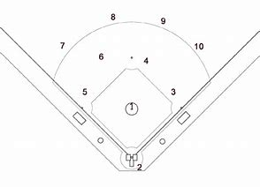

- Name the base by each arrow.

